Statistical Inference Lab Session
Lee Barnby
2024-10-03

Lab Session 2: Statistical Inference

Area under the Normal Distribution Curve
- Approximately 95% of the area under the normal curve lies in the interval given by $μ±2σ$.
- For $μ=0$ and $σ=1$ (the standard normal distribution):
  - The upper interval limit is at the quantile 97.5.
  - The lower interval limit is at the quantile 2.5.
  - qnorm(0.975) gives 1.959964.
  - qnorm(0.025) gives -1.959964.
  - These values are approximately $±2$. Insert a code block to verify this.

99.7% of the Normal Curve’s Area
- This area spans the interval $μ±3σ$.
- Quantile limits are 0.15% and 99.85%.
  - qnorm(0.9985) and qnorm(0.0015) give 2.967738 and -2.967738.
  - This interval is approximately $±3$. Insert a code block to verify this. Why are the values identical, apart from their sign? ## 68% of the Normal Curve’s Area
- This area covers $±1σ$ from the mean $μ$. Use the qnorm function to find the exact quantiles for this interval.

Test for a Data Set Being Normally Distributed
We’ll use the trees dataset as an example:
# Load data
data(trees)
# Histograms
hist(trees[,1])
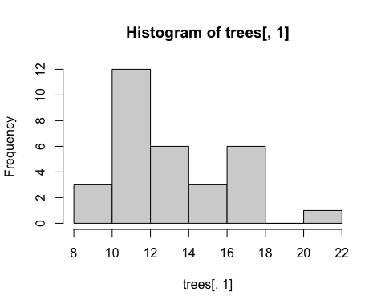 Repeat this for the second and third columns. You might want to use the help function to look up what these data represent.
# QQ plots
qqnorm(trees[,1])
qqline(trees[,1])
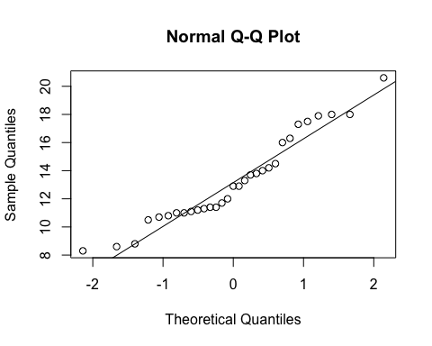
# Shapiro-Wilk test
shapiro.test(trees[,1])
##
## Shapiro-Wilk normality test
##
## data: trees[, 1]
## W = 0.94117, p-value = 0.08893
# Box plot
boxplot(trees[,3])
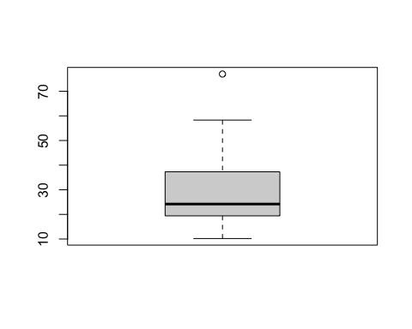

Example from Lecture
A random sample of 80 tablets had an average potency of 15mg with a known standard deviation of 4mg.
# 95% confidence interval
qnorm(0.025, mean=15, sd=4/sqrt(80))
## [1] 14.12348
qnorm(0.975, mean=15, sd=4/sqrt(80))
## [1] 15.87652

Confidence Intervals
- 95% confidence interval for the population mean $μ$ is given by:
$$\overset{‾}{x}±1.96×\frac{σ}{\sqrt{n}}$$
- Example: The weight of eggs sold by a grocery store is normally distributed with a standard deviation of 18 grams. A sample of 20 eggs has an average weight of 42 grams.
# 95% confidence interval
mean_weight <- 42
sd_weight <- 18
n <- 20
error <- qnorm(0.975) * (sd_weight / sqrt(n))
ci_lower <- mean_weight - error
ci_upper <- mean_weight + error
ci_lower
## [1] 34.1113
ci_upper
## [1] 49.8887

Lab Session 3: Statistical Inference with Students t-Distribution

Example from Lecture
26 measurements of the potency of a single batch of tablets:
x <- c(498.38, 489.31, 505.5, 495.24, 490.17, 483.2, 488.47, 497.71, 503.41, 482.25, 488.14, 492.22, 483.96, 473.93, 463.4, 493.65, 499.48, 496.05, 494.54, 508.58, 488.42, 463.68, 492.46, 489.45, 491.57, 489.33)
mean(x)
## [1] 490.0962
sd(x)
## [1] 10.78317
Can you use the ‘qt()’ command to find the 95% confidence interval for the mean potency of the batch?

Confidence Intervals when the Data is Normally Distributed
- 95% confidence interval for the sample mean when the variance is known:
$$\overset{‾}{x}±1.96×\frac{σ}{\sqrt{n}}$$
- Example with known standard deviation:
x2 <- c(238, 474, 359, 256, 481, 323, 151, 340, 284, 417, 424, 309, 139, 237, 269, 46, 350, 408, 223, 408, 286, 224, 238, 119, 343)
mean(x2) + qnorm(0.975) * (sd(x2)/sqrt(25))
## [1] 337.4194
mean(x2) - qnorm(0.975) * (sd(x2)/sqrt(25))
## [1] 250.2606
What is wrong with this calculation?

Determination of Sample Size for Estimating a Population Mean
- Example: The weight of eggs sold by a grocery store is normally distributed with a standard deviation of 8 grams. Compute the sample size needed for a 99% confidence interval with an interval width of at most 2 grams.
sd_eggs <- 8
z_alpha <- qnorm(0.99)
epsilon <- 2
n <- (z_alpha * sd_eggs / epsilon)^2
n
## [1] 86.59031

Documeent converted from pdf bu Co-pilot, edited and compiled by Lee Barnby on 2024-10-03.

